Dear Current Provider,

For those of you who I have not yet spoken with, my name is Tony Suttle. I am the LifeStream Quality Control Manager, taking over the position previously held by Rich Ivy. I have been with LifeStream two years as an In-Home Care Manager and look forward to working with each of you.
First, I want to thank you for all you do for the individuals we serve every day. I know this past year has been especially challenging and on behalf of those we serve, thank you for all of the adapting you have done in the past year. It is greatly appreciated.
LifeStream Services is starting the process of updating our provider agreements for the next two year cycle. Our current provider contracts run through June 30, 2021. The new contracts will run from July 1, 2021 to June 30, 2023.
We are sending this letter to our current providers to inform you the renewal paperwork is available on our website at www.lifestreaminc.org/providers. All of the completed applications are due in our office by 5pm on Friday, June 4, 2021. We will then get them approved, signed and a copy returned to you.
If you have any questions, please let me know. I can be reached at 765-759-1121 or tsuttle@lifestreaminc.org.

Sincerely,
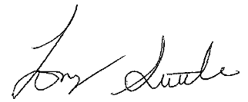
Tony Suttle
Quality Control Manager
LifeStream Services

